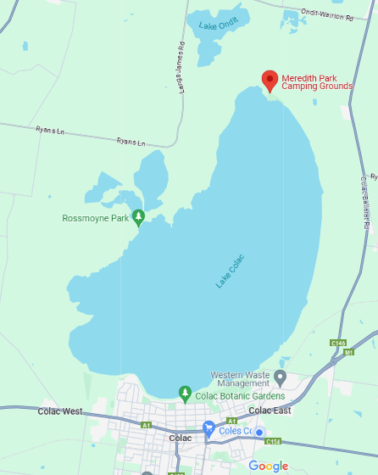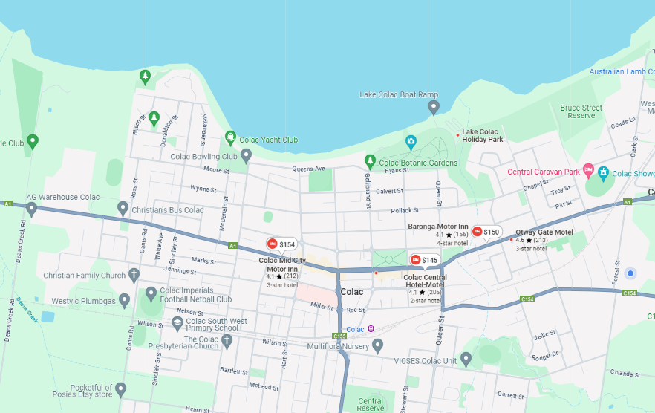Accomodation

Lake Colac Holiday Park - <https://www.lakecolacholidaypark.com.au/>

Meridith Park Camping Grounds – Free Camping <https://www.colacotway.vic.gov.au/Parks-Recreation/Meredith-Park>

Otway Gate Motel - <https://www.otwaygatemotel.com.au/>

Colac Central Hotel/Motel [https:/www.colaccentralmotel.com.au/](https://www.colaccentralmotel.com.au/)

Colac Mid City Motor Inn - <https://www.colacmidcitymotel.com.au/>

Colac Otway Caravan & Cabin Park - <https://kuiparks.com.au/parks/colac-otway-caravan-cabin-park>

Food

Salad rolls, pies and sausage rolls, canteen snacks Meal Provided Friday and Saturday nights

Bar – drinks at bar prices